1. What is Entity Framework (EF), and what is it used for?

EF is an object-relational mapping framework that simplifies data access.

1. In the Movie model, what is the ID field used for?

The ID field is used as the primary key.

1. In the Movie model, [DataType(DataType.Date)] is a type of data
2. What does Scaffolding a model produce?

Scaffolding a model produces create, details, edit, delete, and index for our movie pages

Aswell as it made a context file

1. What json data name was created in the appsettings.json file for the database connection after scaffolding the Movie model?

A RazorPagesMovieContext data connection was created within the appsettings.json file.

After answering this question, do a screen print to verify your answer.

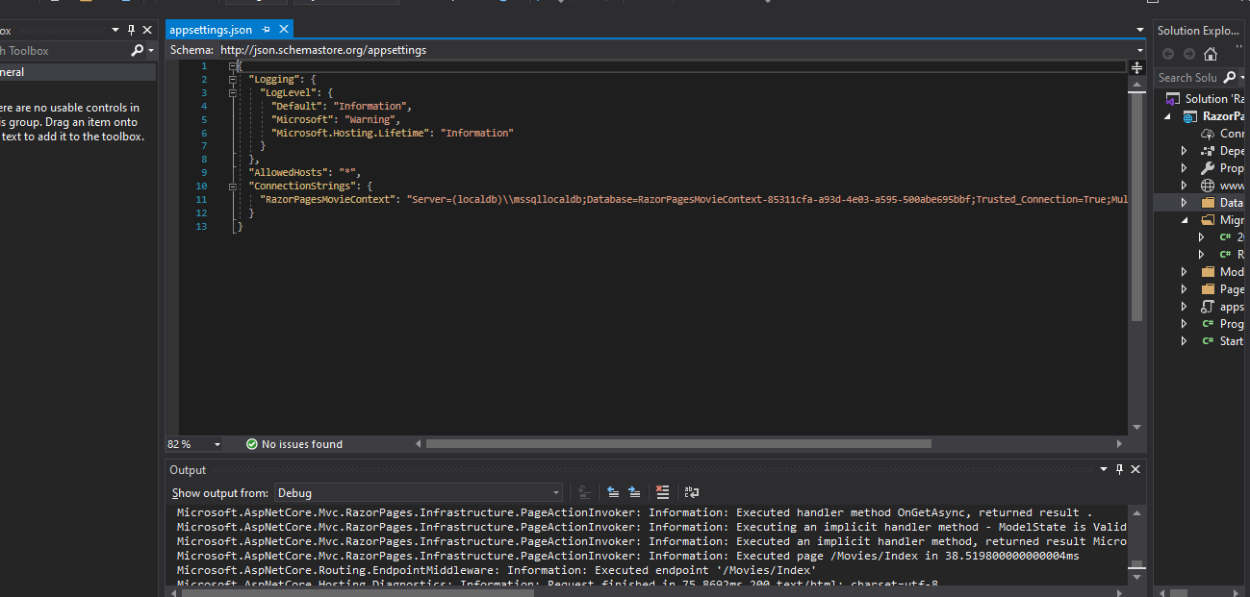

1. What files were produced in the Pages/Movies folder after scaffolding?

Create.cshtml, Delete.cshtml, Details.cshtml, Edit.cshtml, and Index.cshtml.

1. What other folder/files were created by scaffolding?

A file Data/RazorPagesMovieContext.cs

1. What tool was used to perform the migration (create/update the database from the Movie model)?

The NuGet Package Manager Console.

After answering this question, do a screen print to verify your answer.

row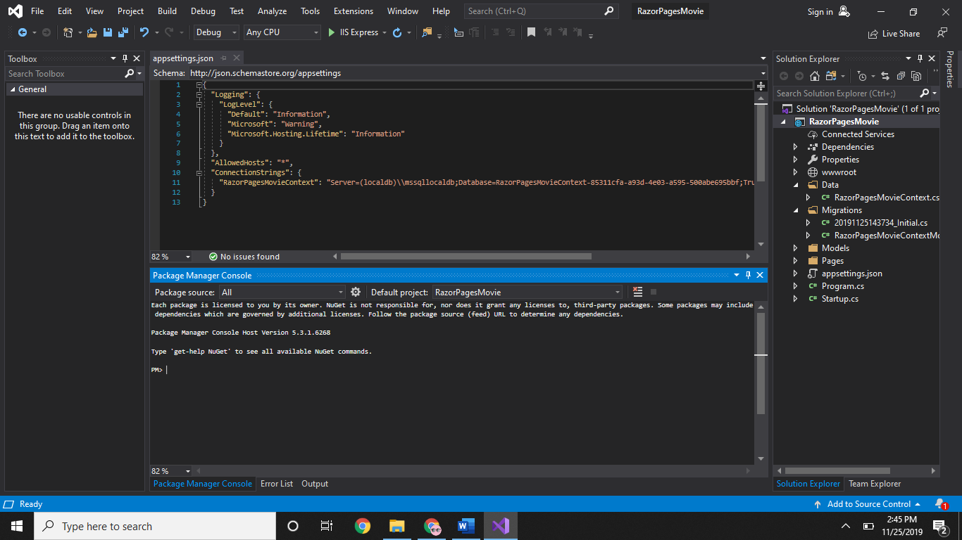

1. Give a brief definition of dependency injection.

Dependency injection is to move dependencies to a base class to make it only available when needed and makes the dependencies abstract.

1. According to EF, an entity set is a database table and an entity is a row in a database
2. Run the application, append movies to the url (/movies), and screen print.

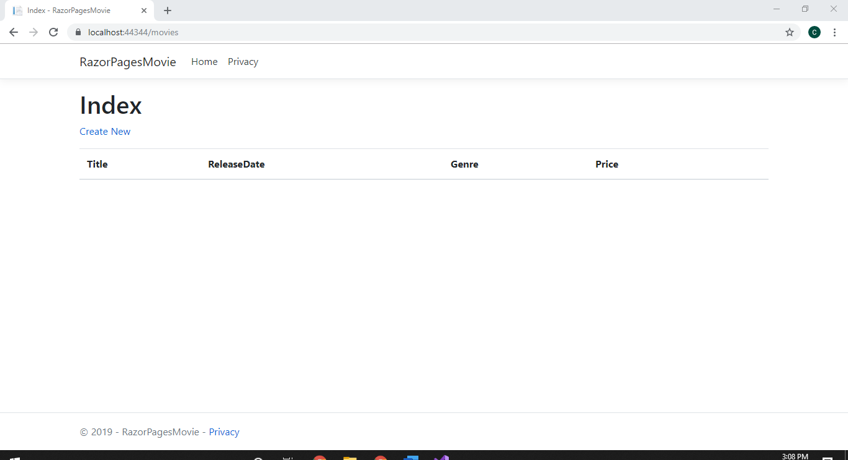

1. Test the Create New feature by entering some data, then screen print. Also experiment with the Details, Edit and Delete options.

